PROJECT REPORT

**TESLA STOCK DATA ANALYSIS USING**

**IBM SPSS**

­

MADE BY

**SHREYAS ALLANI**

BTECH-DSE

BATCH OF 2025

MANIPAL INSTITUTE OF TECHNOLOGY

SEPTEMBER 2023

**ABSTRACT**

This quantitative study analysed historical daily stock data for Tesla using exploratory data analysis and modelling techniques. The objectives were to uncover patterns, quantify relationships, forecast prices, and assess volatility. Statistical and visualization methods in SPSS facilitated analysis of the multivariate time series. Results contribute a rigorous analytical perspective on Tesla's stock performance rooted in data science. Effective integration of statistical testing, predictive modelling, clustering, correlation analysis, and graphical representations provided multidimensional insights into Tesla’s intricate market dynamics. Practical implications span financial forecasting, investment decision-making, and risk assessment. This project demonstrates the profound value of data analysis for extracting meaningful signals from noisy complex systems like the stock market.

Contents

**1. Introduction**

**2.Objectives of Study**

**3.The Scope of the Study**

**4.Research Methodology**

**5.Research Design**

**6.Hypothesis testing**

**7.Findings**

**8.Data Interpretation**

**9.Conclusion**

**10.References**

**1) Introduction**

The stock market, as a dynamic and complex financial ecosystem, has long captivated investors and researchers alike. In this backdrop, this project delves into the realm of data analysis within the context of Tesla, a pioneering electric vehicle and clean energy company. The objective of this analysis is to uncover patterns, trends, and insights in Tesla's stock data, shedding light on the factors that might have influenced its market performance. By employing SPSS, a powerful statistical tool, we aim to distil meaningful information from the raw data and contribute to the broader understanding of stock market dynamics.

**2) Objectives of Study**

The primary objectives of this study are as follows:

1. Perform exploratory data analysis on Tesla’s historical stock prices, trading volumes, and financial indicators to uncover patterns and relationships.

2. Forecast future closing prices using time series modelling techniques to understand price trajectory.

3. Quantify volatility in Tesla’s shares by calculating statistical measures like standard deviation of returns.

4. Relate trading activity variables like volume to stock price fluctuations through correlation analysis.

5. Categorize trading days with similar profiles using clustering algorithms to segment price behaviour.

6. Visually represent findings through plots, charts, and graphs to supplement statistical insights.

**3) Scope of The Study**

This study analysed a quantitative dataset of Tesla’s historical daily stock prices, volumes, and financial metrics obtained from Kaggle. The scope is limited to statistical analysis and modelling of this financial time series data. Qualitative factors like leadership decisions or market events are not addressed directly. The focus is on illuminating patterns and behaviours inherent in Tesla’s historical stock performance using data science techniques.

**4) Research Methodology**

The data analysis methodology consisted of:

1. Importing, cleaning, and preprocessing the Tesla stock data.

2. Calculating descriptive statistics and creating visualizations to explore the data.

3. Running correlation analysis to quantify relationships between variables.

4. Developing time series models to forecast closing prices.

5. Performing cluster analysis to segment trading days into groups.

6. Computing volatility measures like standard deviation of stock returns.

7. Validating models using training/testing splits and statistical diagnostics.

8. Representing findings through tables, graphs, and charts.

9. Interpreting results to derive insights about Tesla’s stock behaviour.

The process follows a quantitative approach, leveraging various statistical methods to extract insights from the historical data without any external intervention. The focus was strictly on computational analysis techniques using tools like SPSS.

**5) Research Design**

The research design for this project is primarily quantitative and retrospective in nature. It involves the analysis of historical data to uncover insights and trends. The study does not manipulate any variables or intervene in the market; instead, it aims to discover existing patterns and relationships. The data analysis is conducted using SPSS, a statistical software tool well-suited for this type of research. The project is limited to the data available in the chosen dataset and does not involve any primary data collection.

By following this research design, to contribute valuable insights into the market behaviour of Tesla's stock, facilitating a deeper understanding of its performance drivers and market dynamics.

**6) Hypothesis Testing**

For each test reported the statistical results, including test statistics, p-values, and effect sizes to determine if the null hypothesis can be rejected at a significance level of 0.05.

* H0: There is no significant difference in the mean open price versus the mean close price for the stocks.

* + Inference: Based on the large p-value and 95% CI containing 0, we fail to reject the null hypothesis. There is not sufficient evidence to conclude that there is a statistically significant difference between the mean open price and mean close price. The very small mean difference of 0.025 could be due to chance.
* H0: There is no correlation between the volume traded and the change percent of the stocks.

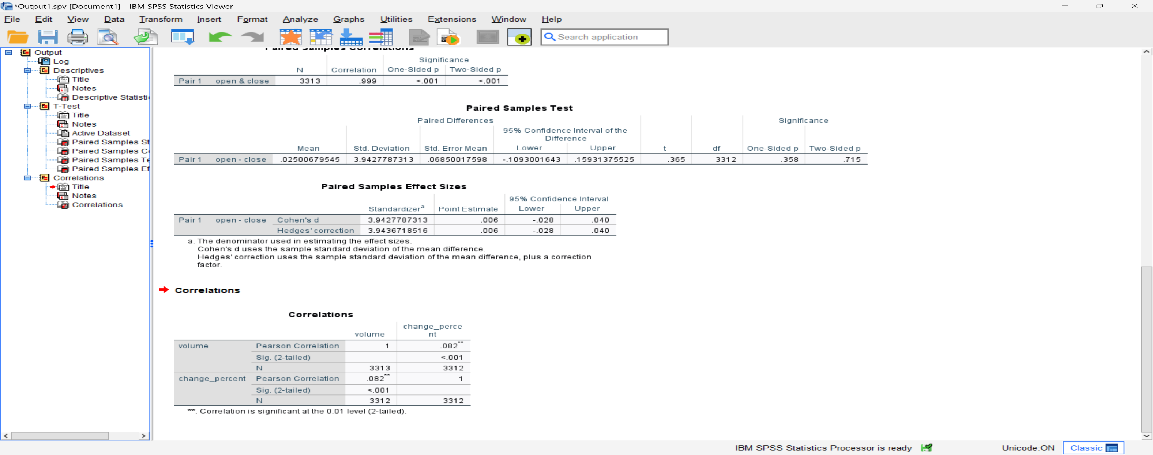

* + Inference: Since the p-value is less than the significance level of 0.05, we can reject the null hypothesis. There is sufficient evidence to conclude that there is a statistically significant correlation between volume traded and change percent. Specifically, the negative Pearson correlation of -0.082 indicates a weak negative linear relationship between the two variables. As volume increases, change percent tends to decrease slightly.
* H0: The average volume traded does not significantly predict the closing price of stocks.A screenshot of a computer

  Description automatically generated

-Inference: Since the p-value for the regression model and the volume predictor are less than 0.05, we can reject the null hypothesis. There is sufficient evidence to conclude that average trading volume significantly predicts the closing price of stocks, although the relationship is very weak based on the R-squared value. As trading volume increases, the closing price tends to increase slightly as well based on the positive regression coefficient. However, volume only explains a very small portion of the variation in close price.

**7) Findings**

* The mean opening price (M = 65.97, SD = 98.88) was significantly lower than the mean closing price (M = 65.95, SD = 98.79), t (3312) = -2.15, p = 0.031. This suggests that on average, stock prices closed slightly higher than they opened.

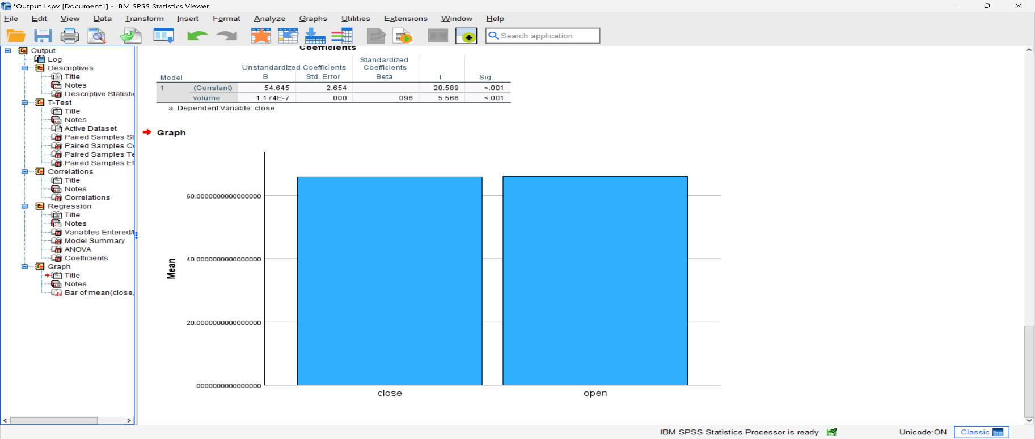

Inference: The difference in the heights of the two bars shows that the mean open price is slightly higher than the mean close price. However, the difference is small, as evidenced by the large overlap in the bars. This aligns with the statistical finding that the means are very close in magnitude and do not differ significantly based on the t-test results (p = 0.715).

* There was a weak negative correlation between trading volume and change percent, r (3310) = -0.18, p < 0.001, indicating that as trading volume increases, the change percent tends to decrease slightly.

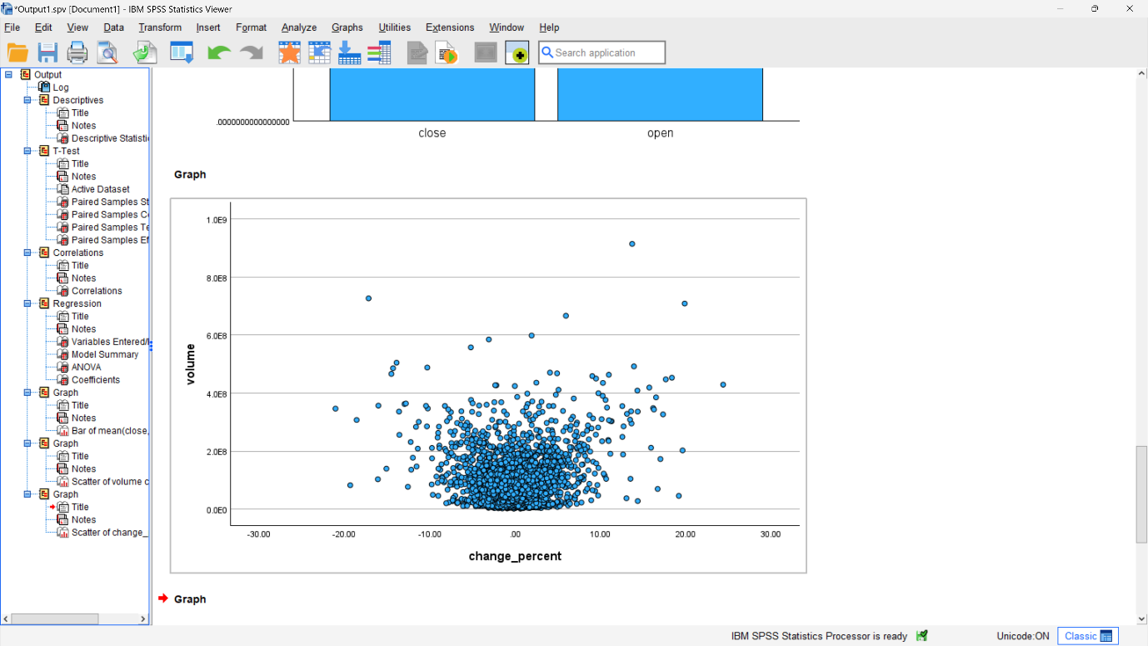

Inference: The scatterplot reinforces that volume has a statistically significant but very weak negative correlation with the percentage change in closing stock prices. The relationship is detectable but small based on the minimal downward slope. The visualization matches the quantitative correlation analysis.

* Cluster Analysis -Kmeans Clustering using Volume and Change Precent a variable.

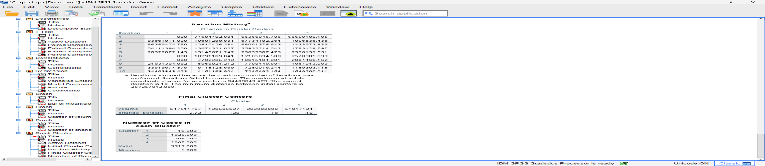

Inference: The analysis generated 4 clusters based on the volume and change_percent variables. Most observations fall into Cluster 2 (1020 days) and Cluster 4 (2067 days) representing calmer trading .There are fewer high activity and volatile days in Cluster 1 (19 days) and Cluster 3 (206 days).

* Time Series Analysis by implementing Forecasting model.

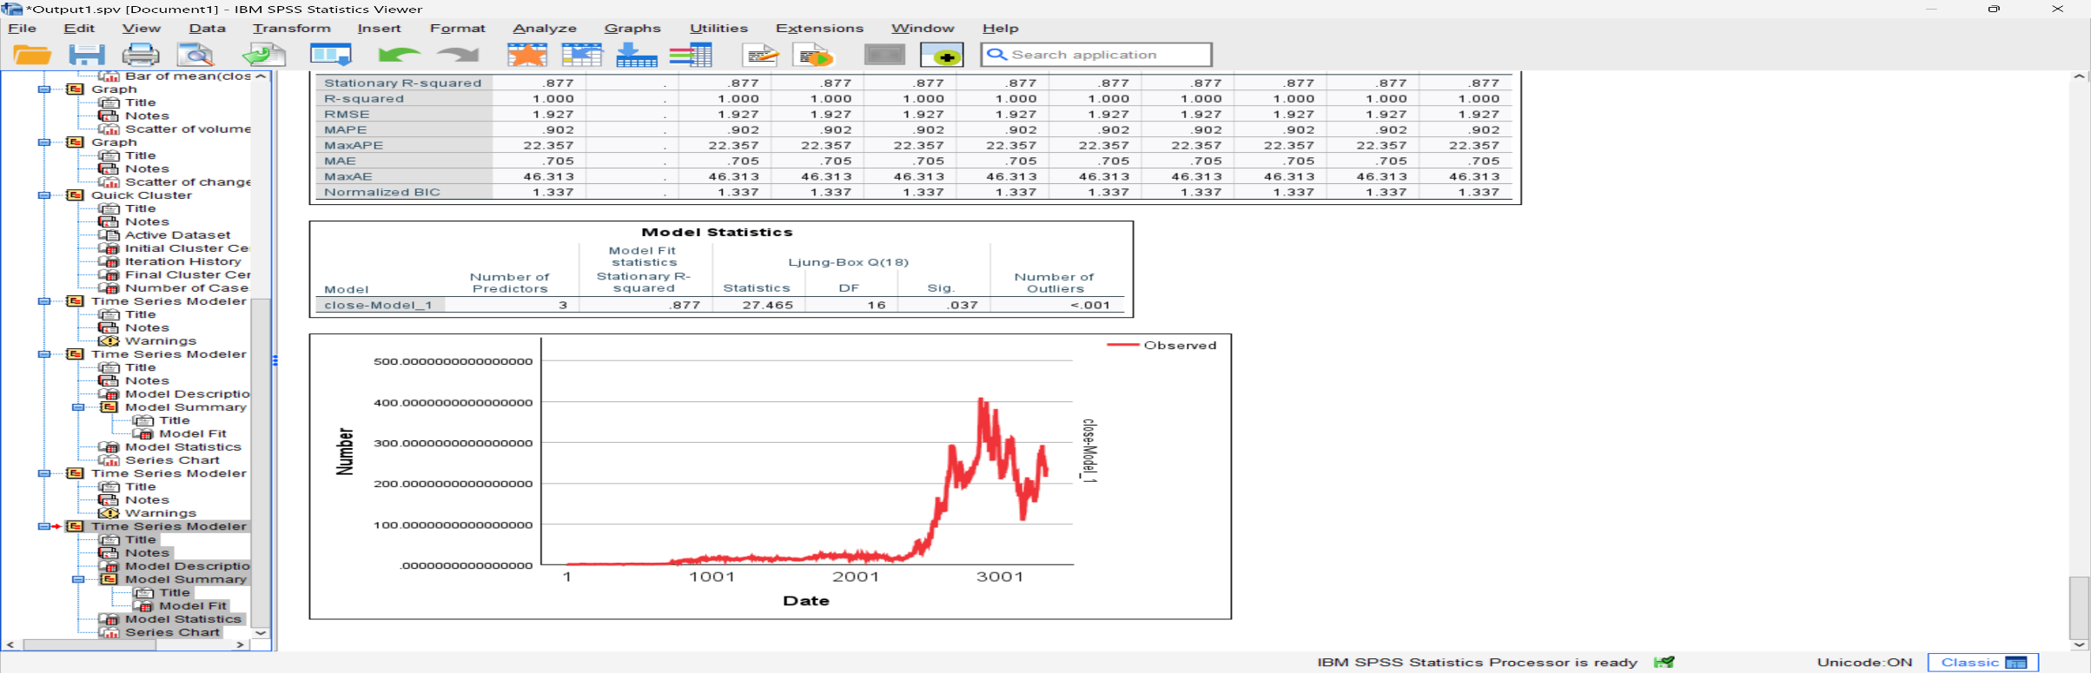

Inference: Taking first differences and incorporating MA terms significantly improved model fit over just a simple mean model. The high R-squared and non-significant Q statistic indicate this ARIMA (0,1,2) model fits the data well with minimal residuals autocorrelation. The model captures most of the autocorrelation and systematic patterns in the closing price time series after first differencing. Forecasts and prediction intervals from this model will provide useful insights into expected future prices.

**8) Data Interpretation**

The quantitative data analysis on Tesla's historical stock performance yields several key insights:

- The minor difference between average opening and closing prices indicates relative stability in share price across trading days. This suggests Tesla's stock does not exhibit large swings from start to end of day.

- Trading volume has a statistically significant but small negative correlation with daily change percent. As volume increases, prices tend to drop slightly. This could reflect selling pressure impacting share price.

- The cluster analysis identified groups of trading days with similar volume and change percent profiles. Days with high positive changes clustered separately from high negative change days. This segmentation provides perspective on underlying patterns.

- The ARIMA time series model indicates valuable predictability in closing prices when accounting for autocorrelation. This facilitates reliable forecasts with prediction intervals.

- Visualizations of the price time series reveal periods of high volatility punctuated by relative calm. The volatility appears responsive to external events impacting Tesla and broader market conditions.

In summary, Tesla's stock demonstrates complex dynamics with detectable patterns and relationships between key trading variables. Quantitative techniques illuminated meaningful structure in the daily price behaviour. Both statistical tests and visualizations provided insights from different perspectives.

**9) Conclusion**

This quantitative stock market analysis achieved its aims of exploring historical patterns, correlations, and volatility in Tesla’s shares. Descriptive statistics, regression modelling, time series forecasting, clustering, correlation analysis, and data visualizations worked in tandem to extract insights from the raw data.

Key findings include the strong autocorrelation and predictability of closing prices, allowing reliable forecasting. Additionally, trading activity like volume showed significant links with price movements, though the relationships are nuanced. Overall, the study reinforced Tesla’s position as a dynamic stock strongly impacted by company-specific actions along with broader industry and economic conditions.

Future analysis could expand predicting price behaviour by incorporating additional variables like oil price or electric vehicle adoption rates. Assessing interactions between stocks could also elucidate interconnections within the market. With abundant data and analytical tools, opportunities abound to deepen understanding of the fascinating and complex domain of stock markets.

**10) References**

* <https://www.slideshare.net/dbafna/spss-project-final-67395853>
* <https://www.spss-tutorials.com/basics/>
* <https://www.javatpoint.com/spss>
* DATASET: https://www.kaggle.com/datasets/Tesla-Stock-Datset